

Keithcot Farm

September September 2023

**Please note - there will be**

**no Department for Education preschool on**

***Monday 4 September***

All core staff across our Preschool, Long Day Care, Allied Health and Community Development will be attending a Profesional Learning Day on 4 September.

Long Day Care will be available to families who have children with a regular LDC booking each Monday. We will be

* Monitoring the progress of our Prior to School Quality Improvement Plans (PQIP’s).
* Planning our PQIP’s for 2024
* Engage in Professional Development in relation to Co Regulation + Self Regulation and Sustained Shared Thinking
* Reviewing our Workplace Health and Safety procedures
* Reviewing our Collaborative Partnerships with Families and Communities; and Governance and Leadership Policies.

**Parent Opinion Survey**

The Parent Opinion Survey is given to parents/caregivers to help us gain feedback about the Children’s Centre and the range of programs that we provide.

The information is collated and then reflected upon during planning processes - the planning of the learning program, the centre priorities, strategic directions and achieving the National Quality Standard (NQS).

The information is also used when completing the Annual General Report.

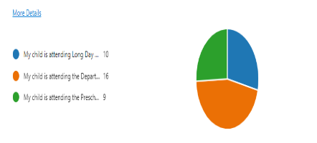**10** responses from families accessing Long Day Care.

**9** responses from families accessing both Preschool + Long Day Care.

**16** responses from families accessing Preschool

Overall the 35 responses indicated a continuing high degree of satisfaction in each of the 7 National Quality Standards

Quality Area 1: Educational Program and Practice.

Quality Area 2: Children’s Health and Safety

Quality Area 3: Physical Environment

Quality Area 4: Staffing Arrangements

Quality Area 5: Relationships with children

Quality Area 6: Collaborative Partnerships

Quality Area 7: Governance and Leadership

A Query was raised about our staff teams understand and implementing of Trauma Informed Practices. Over the years our Staff team has accessed SMART (Strategies to Manage Abuse Related Trauma) as well as more recently “Understanding Trauma, recognising the signs and supporting the child in the early years setting”. Throughout this year we have been working with Department for Education Occupational Therapists investigating evidence-based strategies in relation to co regulation and self-regulation.

A concern was raised in relation to Speech Pathology services. The Department for Education Support Services Team is experiencing unprecedented staffing challenges. The Speech Pathology team is currently at 40 percent capacity impacting directly on children accessing Speech Pathology services in 2023. We are hopeful that this situation will improve in 2024.

**Curriculum**

Caitlyn Davies-Plummer, a professional First Nations artist has commenced working with our children across our integrated site. This is one of our Actions in relation to our Reconciliation Action Plan (RAP). This shared learning experience supports our understanding of local First Nations history, culture, and language. By being involved in a hands-on experience gives children an opportunity to develop positive relationships with a First Nations person and participate in an authentic, educational, and inclusive partnership. We are hopeful that this collaboration with a First Nations artist can be a long term, sustainable relationship that is rich and rewarding for all children and Educators at our site. Caitlyn will be returning on Monday 18 and Monday 25 September

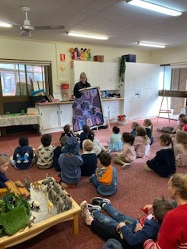

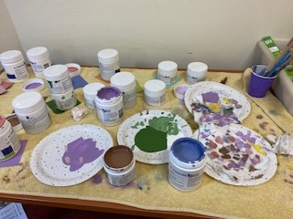

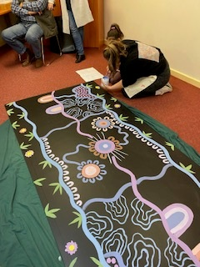

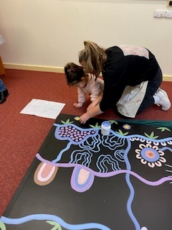

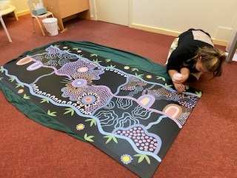

Once the murals are completed, we will proudly display them and acknowledge all participants, transforming our thinking and actions in a creative and meaningful way for all to appreciate.

**Community Development Update**

**Being with Baby**: recommenced 29th of August.

**Big feelings**: “Being with Big Feelings” is a series of 4 workshops focusing on supporting parents to better understand the emotional world of their children.

**Blended Therapy:** continuing to offer their NDIS funded support group on Thursday mornings.

**Drop in and chats:** will continue to be offered throughout the year and using all other programs as a referral for this service.

**Infant Massage:** will commence Fridays at the end of August.

**Learning Together Playgroup:** Tuesday mornings but due to high demand still has a waiting list.

**My Time:** Is a peer support program for parents and carers of children with a disability, developmental delay, or chronic medical condition on Friday afternoons.

**Parent capacity building programs: we are** working with the Tea Tree Gully Council, to organise a Toileting and transition to school workshops for early in term 4.

**Play in the park:** The Tea Tree Gully Council are keen to support the Play in the Park program. They will be using their social media platform to be able to promote the sessions. More information will be available very soon.

**Speak and sing**: a new group will start from Wednesday the 6th of September for children with more specific speech and language needs.

**Please contact Nathan (CDC) for more information**

* **in person at the Centre**
* **by phone 0435 219 942**
* **Email: Nathan.mcguinness3@sa.gov.au**

**Dates to Remember**

**Monday 4 September:** No Preschool Program. Long Day Care only for children with a Monday Booking.

**Monday 25 September:** Governing Council Meeting 6.30pm via Microsoft TEAMs

**Friday 29 September:** Last Preschool Day for Term 3.

***Long Day Care continues through the***

***October School Holidays***

**Monday 2 October:** Public Holiday

**Monday 16 October:** Preschool resumes for Term 4.

**Thursday 7 December @ 6.30pm**:

End of Year Family Celebration @ Golden Grove High School – more information will be sent home soon**.**

**Monday 11 December @ 6.00pm:**

Annual General Meeting **–** more information will be sent home soon**.**

**Friday 15 December Whole Centre will be closing for 3 weeks @ 12.30pm**